
Home Meaningful Math Management (Hmmm!)
Preschool Level


CREDITS:
- Clean my room 2 stickers

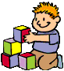
- Pick up my toys 2 stickers
- Brush my teeth 1 sticker
- Wash my hands 1 sticker
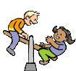
- Share nicely 3 stickers

