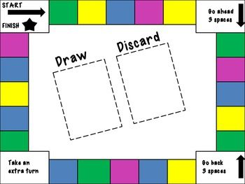

Draw and Answer

Take an extra turn

Go back

3 spaces

Go ahead 3 spaces

Start

Finish