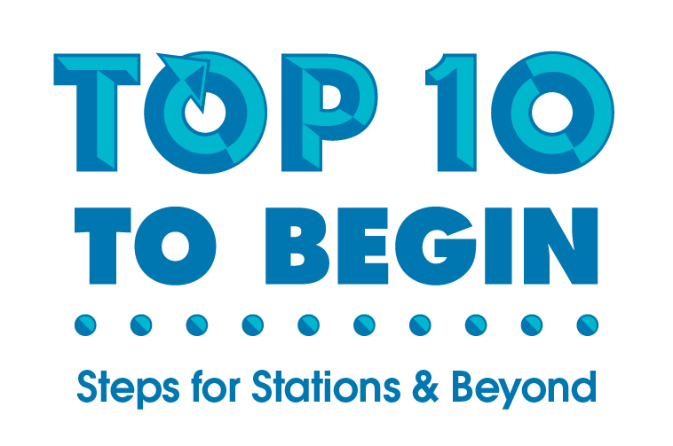
To:

From:

Re: Top 10 to Begin, Steps for Stations & Beyond

Hi [insert name]. I'm writing to get your approval to participate in a terrific educational opportunity. It’s the Top 10 to Begin training on, [insert date and location].

The Tabor Top Ten for Stations & Beyond Training is research-based and brings results every time the strategies are implemented. The presenter, Glenna Tabor, is a nationally known education expert whose training is always highly interactive and mirrors what I will do in the classroom.

The training will:

- Explore the first ten steps that ensure success in implementing small-group, differentiated instruction in every classroom.
- Provide participants with practical ways to build student discourse, engage all learners, and optimize Tier 1 instruction.
- Give every participants an opportunity to experience each of the steps while learning about the steps.
- Teach participants how to cultivate a classroom community that manages itself and motivates students to learn.
- Ease all participants into sophisticating the instruction in their classroom.
- Help participants plan for implementing the ten steps beginning the next day!

The website with registration and information is glennatabor.com.

Pricing is 2 for 1, so two classroom teachers could attend the November 8 training for just $297. Administrators and instructional coaches receive free enrollment with at least 2 teachers attending.

This is an opportunity to get the training I need to sophisticate and fine-tune my instructional pedagogy. I’m very excited about this training and would really appreciate your support and buy-in on my attendance.

I hope to hear from you soon.

Sincerely,
[Your name]

